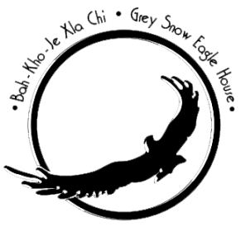
Raptor Cage Sponsor Form
Cage Choices
Cage Cost
Main Flight $75.00
Mini Flight $75.00
Q1
MINI
ED
WEST
EAST
MAIN
West Flight $75.00
Q2
East Flight $75.00
Education Cages $75.00
WTHR
South East Flight $55.00
Main tour route
SE
Weathering Cage $55.00
REHAB
Rehabilitation Flight $45.00
Q-Cages (1&2) $45.00

Please complete the form below:

Name: __________________________________________________________________________________________________________
Address: _______________________________________________________________________________________________________
City: ________________________________________ State: __________________________________ Zip: ___________________ _
Phone: _____________________________________ Email: _______________________________________________________ ____
Signature: ______________________________________________________________________________________________________
Engraving: 2 lines, up to 18 characters per line. (Plaque size: 2”x 3 ½”)Plaque will be featured in the walk-ins of each cage.

Line 1:

Line 2:

Please mail the completed form with a check payable to Grey Snow Eagle House:

Iowa Tribe of Oklahoma
Grey Snow Eagle House
Attn: Ashley LoneTree
335588 E 750 Road
Perkins, OK 74059

