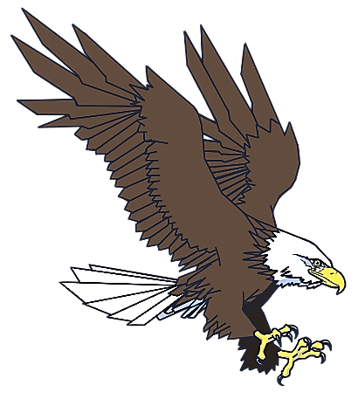
Grey Snow Eagle House
FLOCK
Welcome to the Flock!
Membership Form

Name(s):
Address:
City: | State: |  |  | ZIP Code:
Phone: |  | E-mail:
Friend $50 - Copy of WingBeat, 10% off gift shop
Family $100 - Copy of WingBeat, 10% off gift shop, periodic mailings during the year, book 1 private
tour annually during non-tour hours using member number
Patron $150- Copy of WingBeat, 10% off gift shop, periodic mailings during the year, book 2 private
tours annually during non-tour hours using member number, discounts on events and
presentations
American Express Discover Visa MasterCard Check Cash
Credit Card Number:

Expiration Date:  M/M Y/Y |  |  | Security Code:
Print Name: |  |  |  |  | Date:
Signature of applicant:

